MACH4METAL

metalworking machinery
Transito 21
6909 DA BABBERICH Netherlands
Tel. +31 (0)316-247123
Fax: +31 (0)316-247956
info@mach4metal.com
www.mach4metal.com

Bank No : 66.52.13.883
IBAN : NL33 INGB 0665 2138 83
BIC : INGBNL2A

AMADA HFE M2 1200 x 50 T

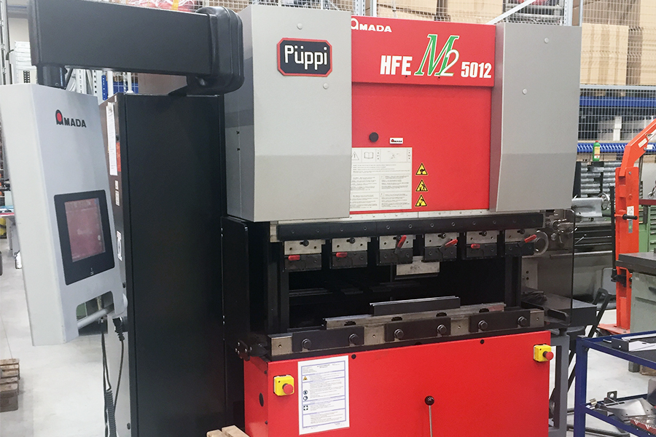
- Make : AMADA Japan
- Typ : HFE M2 5012
- Mach. No. : F 100021
- Age : 06 . 2011

- Max. Pressure : 50 T
- Max. Bending length : 1.270 mm
- Dis. between column : 1.035 mm

- Stroke : 150
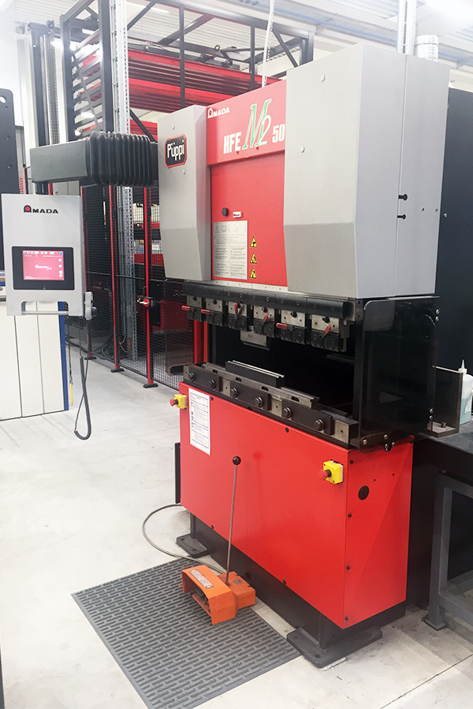
- Throat : 100
- Die height : 370
- Table width : 60

- Approch speeds : 100 mm/M
- Working speeds : 50 mm/M
- Return speeds : 100 mm/M

- Amada AB PAD Touch screen
- X / R Axis

- Dimensions
- Length : 2710
- Width : 2320
- Height : 2300
- Weight : 2550
- Power : 6 kW

- Only 3500 hours
- Some tools
- New EUR 60.000

Please Note: The above information has been obtained to the best of our ability and belief from, and from the manufacturers where possible. It is given in good faith, but its accuracy can not be guaranteed. Accordingly, it will not form a representation or constitute contractual terms. We advise you to check any vital details!

